**Project Report**

**On**

**“Online Examination System”**



**Submitted By: Guided By:**

1. Muskan Mathur Mr. Sanjay Rathore

2. Nikhil Pareek Mr. Ankush Sharma

3. Ayush Jain GRRAS SOLUTION Pvt. Ltd., Jaipur

4. Noble Rathi

5. Pankaj Memrot

6. Shivansh Maheshwari

**Online Examination System**

**A Project Report Submitted**

**in Partial Fulfillment of the Requirements**

**for the Degree of**

**Bachelor of Technology**



**JECRC Engineering College and Research Centre, Foundation**

**(Department of Computer Science & Engineering)**

**RAJASTHAN TECHNICAL UNIVERSITY**

**CERTIFICATE**

This is to certify that the Industrial Training Project Report entitled ExamBuzz, submitted to the Department of Computer Science and Engineering, Rajasthan College of Engineering for Women, Jaipur, for partial fulfilment of the Degree of Bachelor of Technology of Rajasthan Technical University, is a record of bona fide work carried out by Miss Muskan Mathur, Roll No. 17ERWCS026, under our supervision and guidance.

All help received by her from various sources have been duly acknowledged.

**Acknowledgements**

The satisfaction that accompanies the successful completion of any project work would be impossible without the mention of the people who made it possible and whose constant guidance and encouragement crown all the efforts. This thesis was only an endeavor but also an interesting learning experience for me and it bears the imprint of a number of people who directly or indirectly were a great source of help and constant encouragement.

I would like to express my sincere thanks to my mentor Miss. Arti Bhardwaj for his continuous motivation. Her valuable suggestions, comments and support were an immense help for me. I am grateful to her for taking out time from their busy schedule and being very supportive in guiding my work.

I would also like to thank the supervisors Mr. Sanjay Rathore, Mr. Ankush and Mr. Rajat Goyal for helping and guiding me throughout with the technical issues.

I am also very grateful to Mr. Sanjay Gaur (HOD, CSE) for his kind support. I would like to take this opportunity to show my gratitude towards Dr. Arihant Khicha (Director) who helped me in successful completion of my Pre-Final Year Industrial Training. They have guided, motivated & were source of inspiration for me to carry out then necessary proceedings for the training to be completed successfully.

Lastly but most importantly, i would also like to thank my father Mr. Kailash Mathur, my mother Reeta Mathur and my brother Rahul Mathur for their constant source of encouragement. It would be impossible to stand here at the end of the road without their endless love, constant support and motivation. I also want to express my gratitude to my friend Nikhil Bansal whose direct or indirect suggestions help me to develop this project.

Muskan Mathur

**ABSTRACT**

ExamBuzz is web-based application for technical evaluation. ExamBuzz not only replace paperwork but also releases the workload of faculty. It fulfills the requirements of the institutes to conduct the exams online. Students can give exam without the need of going to any physical destination. They can view the result at the same time. Thus, the purpose of the site is to provide a system that saves the efforts and time of Faculty.

**CONTENTS**

**Certificate I**

**Acknowledgement II**

**Abstract III**

**Chapter 1. Introduction 01**

**1.1 Introduction. . . . . . . . . . . . . . . . . . . . . . . . . . . . . . . . .. .**

**1.2 Purpose. . . . . . . . . . . . . . . . . . . . . . . . . . . . . . . . . . . . . . ..**

**1.3 Scope. . . . . . . . . . . . . . . . . . . . . . . . . . . . . . . . . . . .**

**1.4 Features. . . . . . . . . . . . . . . . . . . . . . . . . . . . . ..**

**1.5 Overview**

**1.6 Technology Used**

**1.7 Taxonomy**

**1.7.1 Create exam**

**1.7.2 Join exam**

**1.8 Existing system**

**1.9 Disadvantage of existing System. . . . . . . . . . . . . . . . . .**

**1.10 Objective of proposed system . . . . . . . . . . . . . . . . . ...**

**Chapter 2: Software Requirement Specification 04**

**2.1 Proposed. . . . . . . . . . . . . . . . . . . . . . . . . . . . . . . . . . .**

**2.2 Scope. . . . . . . . . . . . . . . . . . . . . . . . . . . . . . . . . . . . . . . .**

**2.3 Specific Requirement . . . . . . . . . . . . . . . . . . . . . . . . . . .**

**2.3.1 Software Requirement. . . . . . . . . . . . . . . . . . . . . . . . . . . . .**

**2.3.2 Hardware Requirement**

**2.4 Constrain . . . . . . . . . . . . . . . . . . . . . . . . . . . . . . . . . . . .**

**2.5 Conclusion . . . . . . . . . . . . . . . . . . . . . . . . . . . . . . . . . .**

**Chapter 3: Design**

**3.1 Data Tables**

**3.2 ER Diagram**

**Chapter 4: Testing and Validation 08**

**4.1 Introduction. . . . . . . . . . . . . . . . . . . . . . . . . . . . . . . . . . .**

**4.2 Design of Test Case. . . . . . . . . . . . . . . . . . . . . . . . . . . . .**

**4.3 Validation . . . . . . . . . . . . . . . . . . . . . . . . . . . . . . . . . . . .**

**4.4 Conclusion . . . . . . . . . . . . . . . . . . . . . . . . . . . . . . . . . . .**

**Chapter 5: Project Footprints**

**5.1 Screen Shots**

**5.2 Bibliography**

**5.3 Future Scope**

**Chapter: 1**

**INTRODUCTION**

* 1. **Introduction**

ExamBuzz is a Multiple-Choice Questions (MCQ) based examination system. It provides an easy to use environment for both Test Conductors and Students appearing for Examination. The main objective of ExamBuzz is to provide all the features that an Examination System must have, with the "interfaces that don't Scare it's Users!".

* 1. **Purpose**

The purpose of ExamBuzz test simulator is to take online test in an efficient manner and no time wasting for checking the paper. The main objective of ExamBuzz is to efficiently evaluate the candidate thoroughly through a fully automated system that not only saves lot of time but also gives fast results and saves test without using extra thing like paper, pen etc.

* 1. **Scope**
* It is a cost-effective and popular means of mass- evaluation system.
* User can create the exam and questions for each exam.
* User can join the exam and can take the exam.
* Scope of this project is very broad in terms of other manually taking exams.

Few of them are: -

This can be used in educational institutions as well as in corporate world.

Can be used anywhere any time as it is a web-based application.

(user Location doesn’t matter).

**1.4 Features**

* Secure
* Easy to use
* Reliable and accurate
* No need of examiner
* Skip and come back to the question afterwards if needed

**1.5 Overview**

* ExamBuzz has following stages
* SignUp
* LogIn
* Created papers
* Joined papers
* View profile
* Update profile
* LogOut

**1.6 Technologies Used**

* Front end as:

HTML, CSS, JS, Angular

* Back end as:

Express, Node

* Database:

MongoDB

* 1. **Taxonomy**

Users of this System can do two things:

• Create exam

• Join exam

* + 1. **Create exam:**

User can create exam using exam name, exam id and exam password.

* + 1. **Join exam:**

User can join exam using exam id and exam password.

* 1. **Existing system**

The Existing system of conducting examination process is manual. Existing system is a large man power process and is difficult to implement it at different platform. It has so many problems. So, we introduce ExamBuzz, which is fully computerized. Existing system is a large man power process and is difficult to implement.

* 1. **Disadvantages of existing system**

• The existing systems are very time consuming.

• It is difficult to analyze the exam manually.

• Results are not precise as calculation and evaluations are done manually.

• Result processing after summation of exam takes more time as it is done manually.

**1.10 Objective of proposed system**

• Economic feasibility

• Time Flexibility

• Technical feasibility

• User-friendly interface

• Eco-Friendly System

**Chapter: 2**

**Software Requirement Specification**

**2.1** **Proposed**

The main objective of the Online Examination System is that it helps educational institutions and corporate world to conduct exams to any number of candidates at a time, in an automated manner. It reduces the time consumption and workload that exist in the current system of examination. It also helps in storing the record of each examination and the results are also stored in the system. This makes the searching of the records easier than the existing system.

**2.2 Scope**

• ExamBuzz can be used in educational institutions as well as in corporate world.

• The system handles all the operations and generates reports as soon as the test is completed which saves the precious time of faculties spent on reviewing answer sheets.

• ExamBuzz is a cost-effective and popular means of mass- evaluation system.

• User can prepare the tests and questions for each exam.

• User can login with their email id and password through which they signed up and can create or join the exam.

• Can be used anywhere any time as it is a web-based application.

**2.3 Specific requirements**

**2.3.1 Software requirement (TECHNOLOGIES USED)**

*Front end as:*

HTML, CSS, JS, Angular

*Back end as:*

Express, Node

*Database:*

MongoDB

*Operating System:*

Windows

**2.3.2** **Hardware Requirement**

• Browser: Chrome

• Processor: Pentium 2.0 and above.

• RAM: 256 MB Server Side:

• Processor: Pentium and above.

• RAM: 512 MB

• Hard disk space: 4GB 2.4 User Requirements Every user should be:

• Comfortably work with computer.

• User must also have basic knowledge of English.

**2.5 Constraints**

• Graphical user interface is only in English.

• Enrolment email id and password is used for identification of user.

• Only registered users will be authorized to use the services.

• *Limited to HTTP or HTTPS.*

*• This system is working for single server.*

**2.6 Conclusion**

In this phase, we understand the software requirement specifications for the system. We arrange all the required components to develop the project in this phase itself so that we will have a clear idea regarding the requirements before designing the project. Thus, we will proceed to the design phase followed by the implementation phase of the project.

**Chapter: 3**

**Data Tables**

**EXAMS:**

|  |  |  |
| --- | --- | --- |
| **S. No.** | **Field Name** | **Description** |
| **1.** | **_Id** | id a unique key, generates at runtime |
| **2.** | **examName** | Name of the exam |
| **3.** | **examId** | Unique id for every exam |
| **4.** | **password** | Store password corresponding to exam name |
| **5.** | **email** | Unique email id for every user who creates exam |
| **6.** | **questions** |  |
| **7.** | **students** |  |
| **8.** | **date** | Unique date on which exam conduct |
| **9.** | **duration** | Time duration of exam |
| **10.** | **time** | Time at which the exam starts |

**USERS:**

|  |  |  |
| --- | --- | --- |
| **S. No.** | **Field Name** | **Description** |
| **1.** | **Name** | Name of the user |
| **2.** | **username** | Store unique username for every user |
| **3.** | **Mobile** | Unique phone number |
| **4.** | **Email** | Unique email id for every user who joins exam |
| **5.** | **password** | Store password corresponding to user name |

**Chapter: 4**

**Testing and Validation**

**4.1 Introduction**

Software testing is a critical element of software quality assurance and represents the ultimate review of specification, design and coding. In fact, testing is the one step in the software engineering process that could be viewed as destructive rather than constructive.

A strategy for software testing integrates software test case design methods into a well-planned series of steps that result in the successful construction of software.

Testing is the set of activities that can be planned in advance and conducted systematically. The underlying motivation of program testing is to affirm software quality with methods that can economically and effectively apply to both strategic to both large and small-scale systems.

**4.2 Design of test cases & scenario**

The objective is to design tests that systematically uncover different classes of errors and do so with a minimum amount of time and effort. Testing cannot show the absence of defects, it can only show that software defects are present.

**4.2.1 System Testing**

Software is only one component of a system. Software will be incorporated with other system components and system integration and validation test performance.

**4.2.2 Validation Testing**

Validation aims to demonstrate that the software functions in a manner that can be reasonably expected by the user. An experiment has done for checking the consistency for the user requirements regarding the username and password which should be validated through the server and the username and password should be matched.

**4.4 Conclusion**

In this way we also completed the testing phase of the project and ensured that the system is ready to go live. Thus, we developed a system that provides a paperless examination.

**Chapter: 5**

**Project Footprints**

**5.1 Screen Shots**

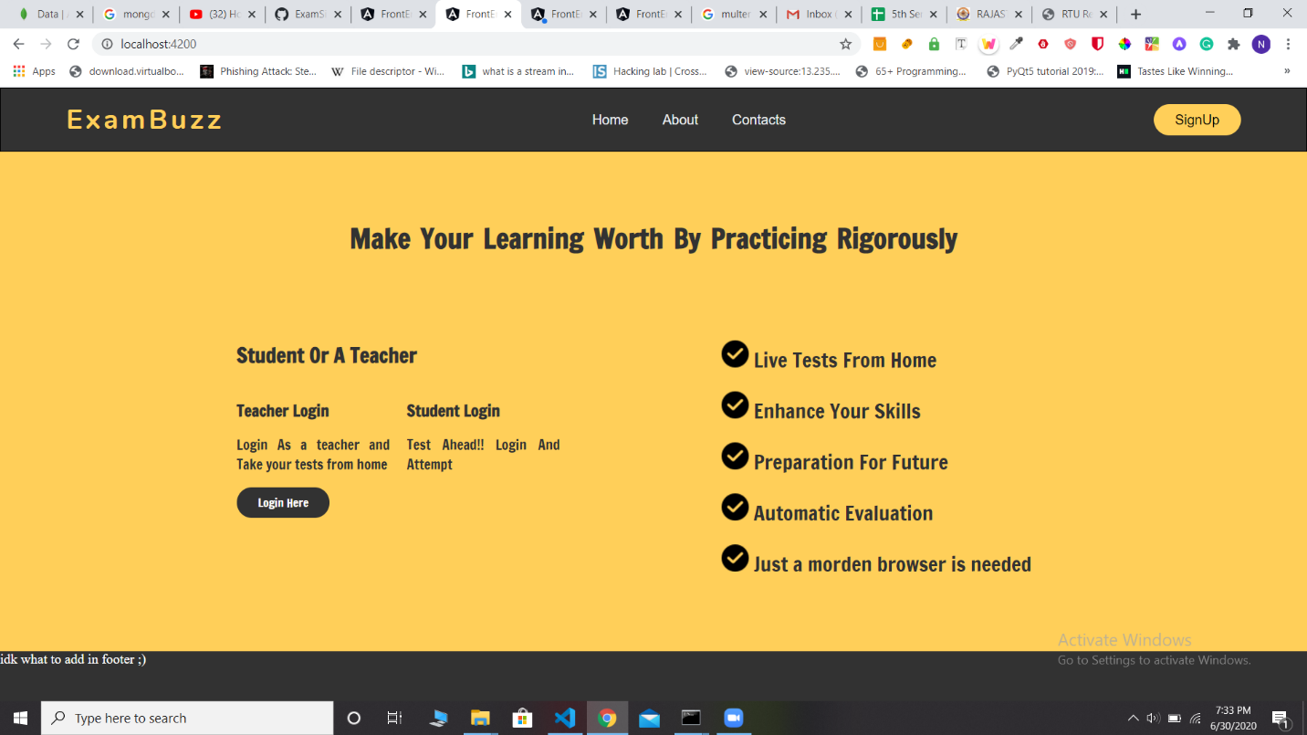

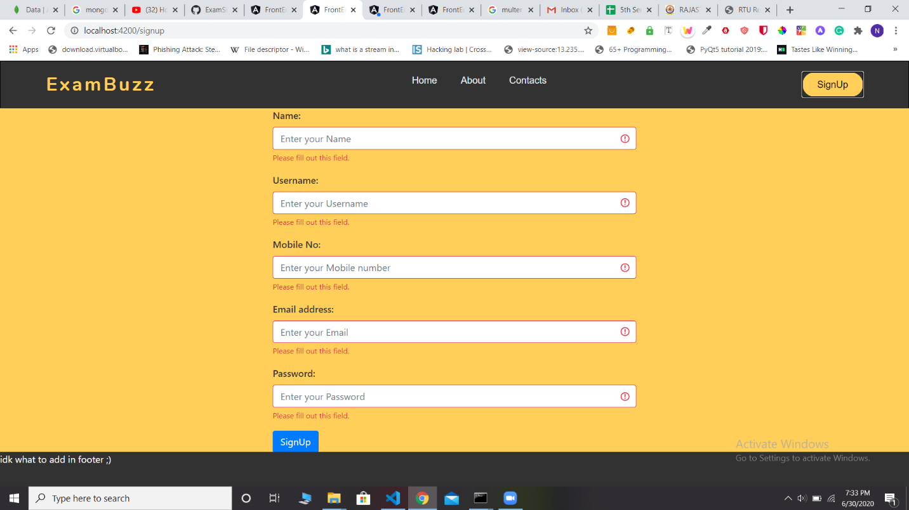

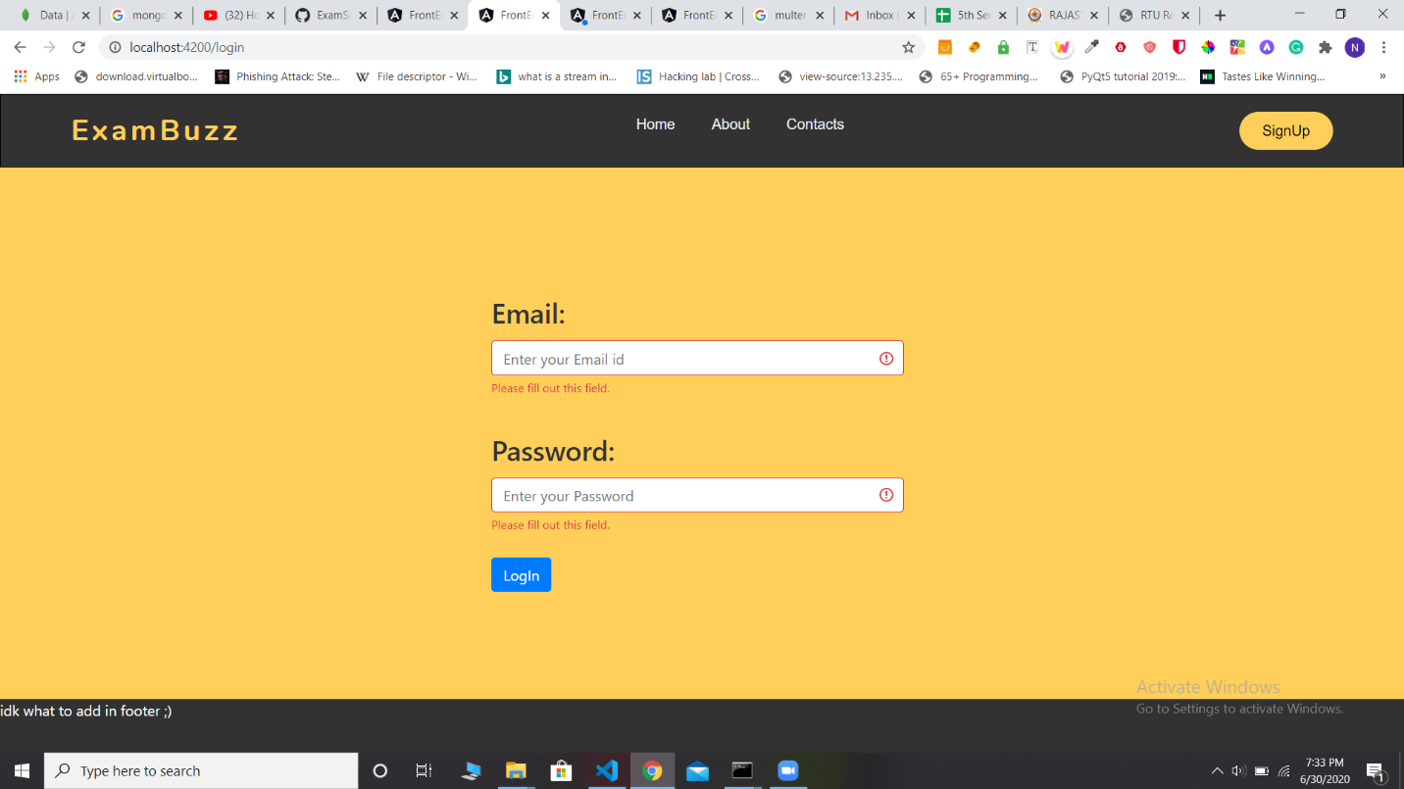

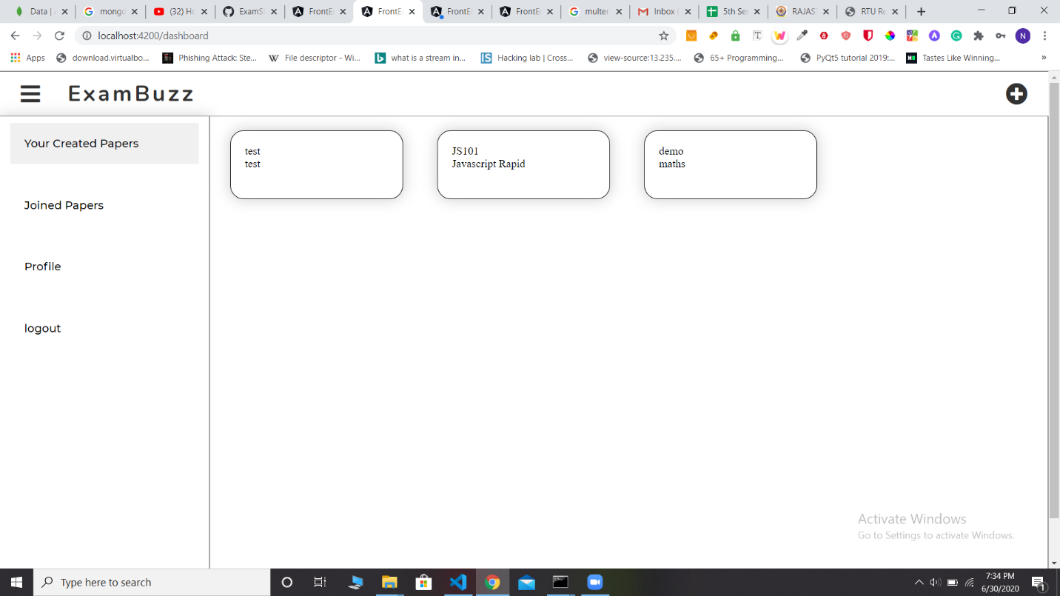

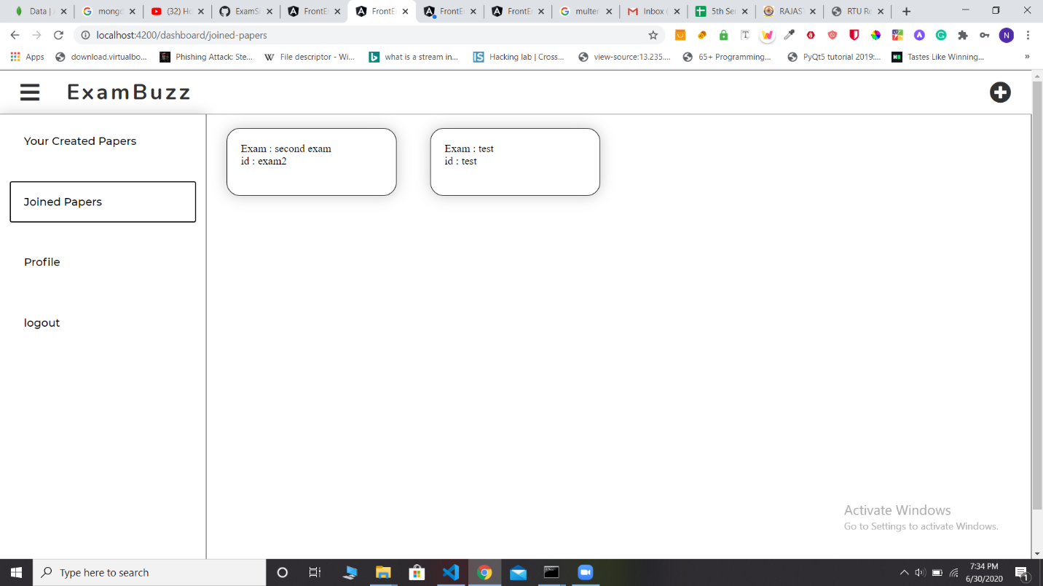

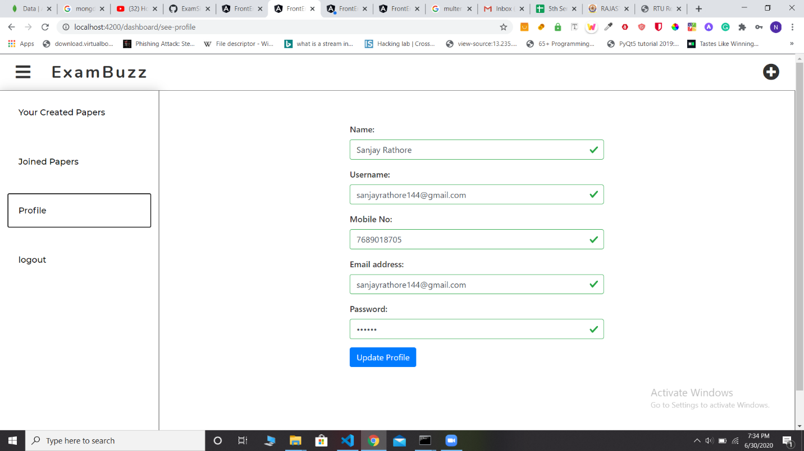

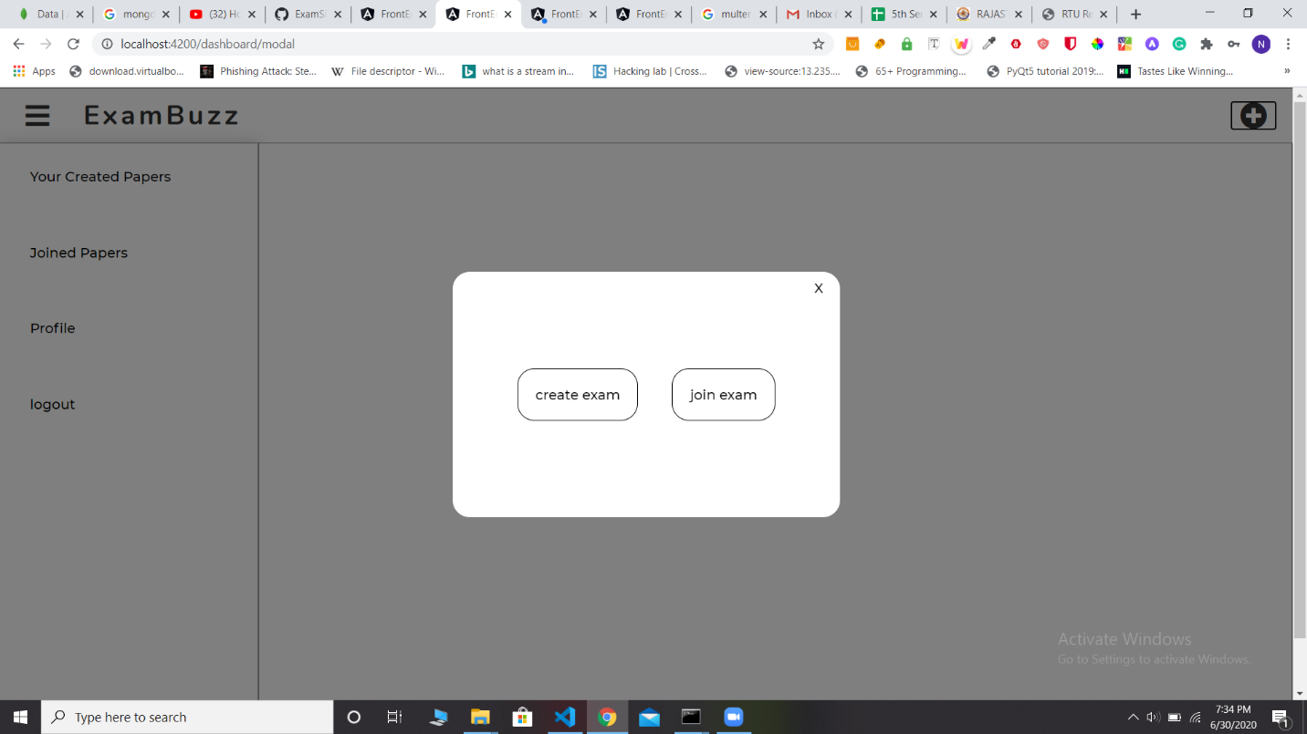

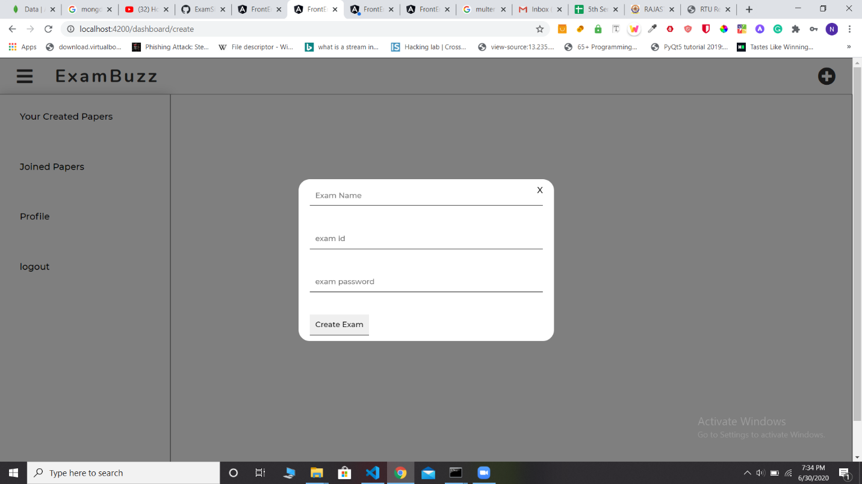

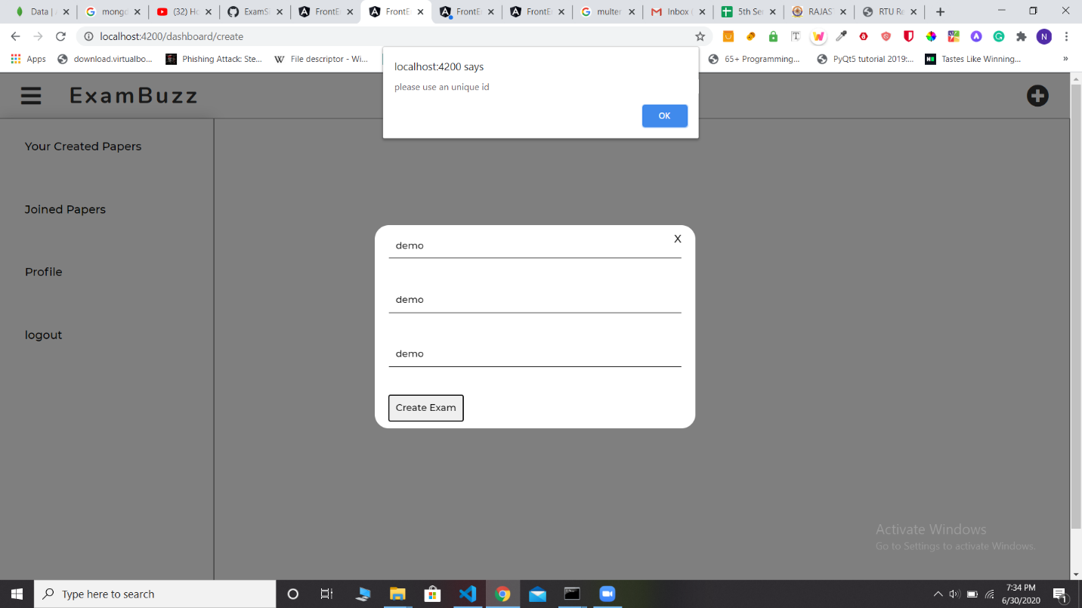

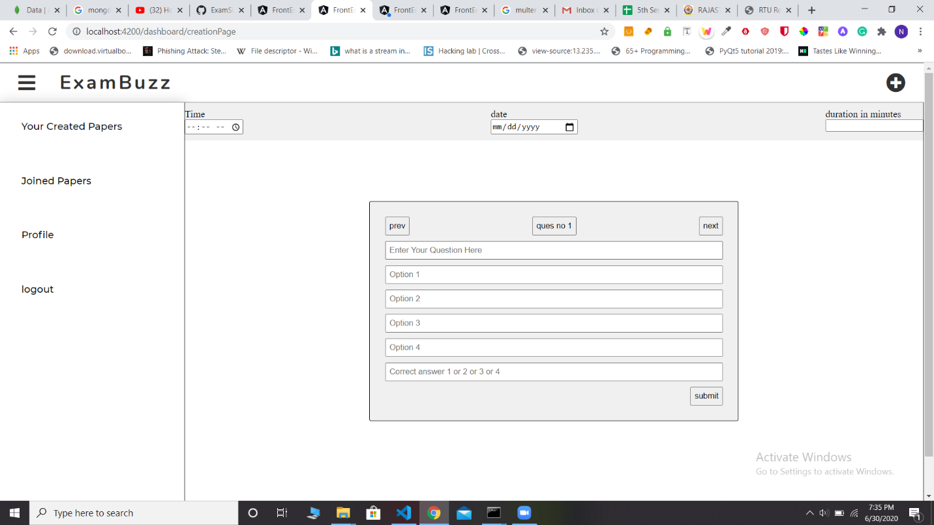

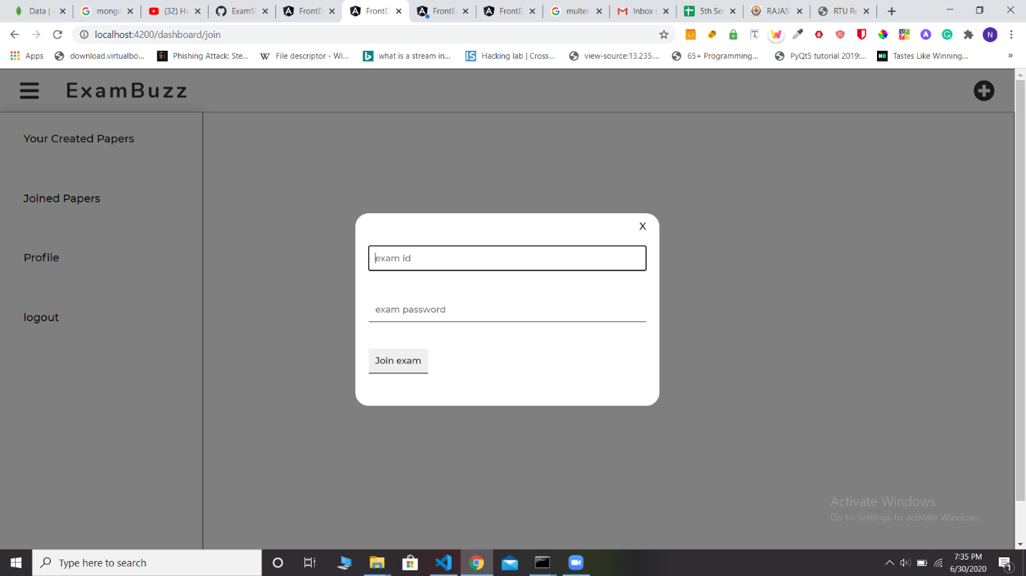

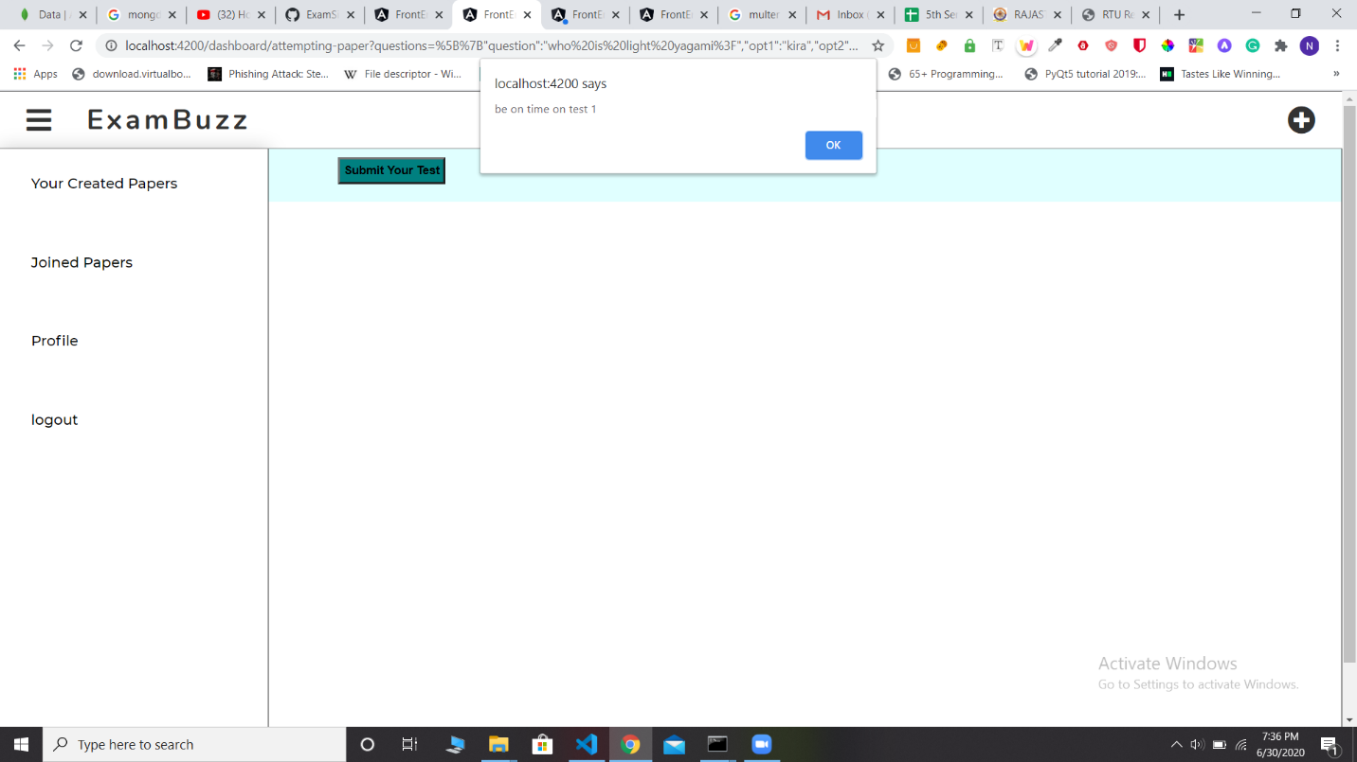

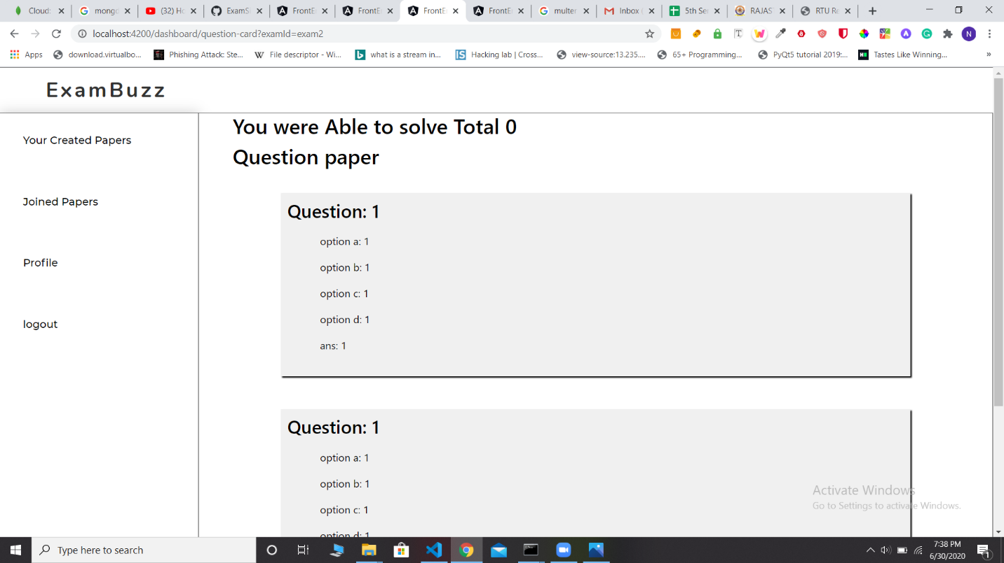

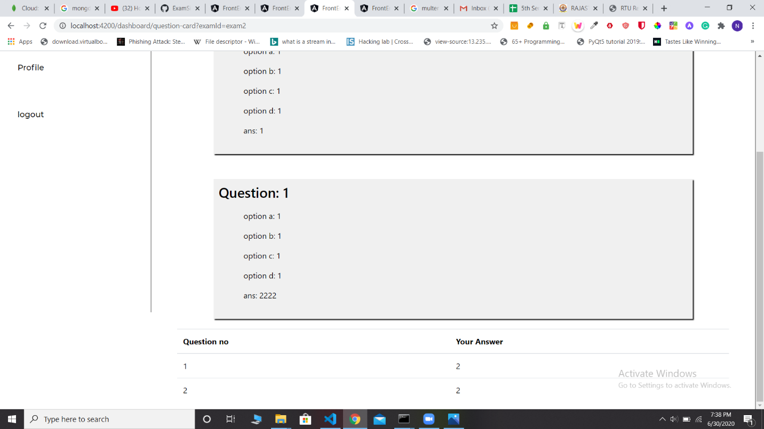

**5.2 Bibliography**

* W3school

**5.3 Future Scope**

* The questions are shuffled in a random order so that possibilities for getting questions in the same order for the students who are besides, is very less.
* Gives the list of attempted and unattempt questions and can go to any question directly and can either attempt or change the answer of the already attempted questions.